Microservices Architecture
# Source: AI Source: Provided by: [Data Path: Persons Table -> ID Column: 1, Name_En Column: Motasem Essam] -> From: [ChatGPT] on [1/23/2026]
Microservices Architecture divides a system into small, independent services, each responsible for a specific business domain. These services communicate via APIs or messaging.
👉 Think of it like a team of specialists, where each person handles one task independently but coordinates with others.

🔑 Key Points
# Source: AI Source: Provided by: [Data Path: Persons Table -> ID Column: 1, Name_En Column: Motasem Essam] -> From: [ChatGPT] on [1/23/2026]
- Each service is independent, deployable, and scalable
- Services are loosely coupled and communicate over APIs or messaging systems
- Promotes flexibility in technology choice per service

🧱 Structure Example
# Source: AI Source: Provided by: [Data Path: Persons Table -> ID Column: 1, Name_En Column: Motasem Essam] -> From: [ChatGPT] on [1/23/2026]
UserService ↔ OrderService ↔ PaymentService ↔ InventoryService
- UserService → Manages user accounts
- OrderService → Handles orders
- PaymentService → Processes payments
- InventoryService → Manages stock

❌ Common Problems (Bad Practice)
# Source: AI Source: Provided by: [Data Path: Persons Table -> ID Column: 1, Name_En Column: Motasem Essam] -> From: [ChatGPT] on [1/23/2026]
- Services tightly coupled
- Hard-coded inter-service calls instead of APIs
- No centralized monitoring, making debugging difficult
class OrderService {
void createOrder(Order order) {
new PaymentService().processPayment(order); // ❌ tight coupling
}
}

✅ Benefits (Good Practice)
# Source: AI Source: Provided by: [Data Path: Persons Table -> ID Column: 1, Name_En Column: Motasem Essam] -> From: [ChatGPT] on [1/23/2026]
- Each service can be scaled independently
- Faults in one service do not crash the entire system
- Different teams can work on different services concurrently
- Services can use different programming languages or databases
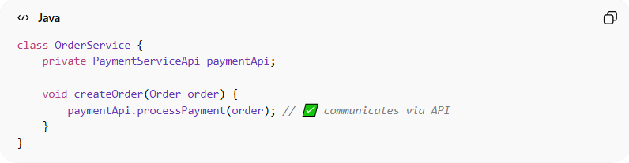
class OrderService {
private PaymentServiceApi paymentApi;

void createOrder(Order order) {
paymentApi.processPayment(order); // ✅ communicates via API
}
}

⚡ When to Use
# Source: AI Source: Provided by: [Data Path: Persons Table -> ID Column: 1, Name_En Column: Motasem Essam] -> From: [ChatGPT] on [1/23/2026]
- Large, complex systems
- Projects needing independent scalability
- Applications requiring team autonomy
- Systems with high availability requirements

